Kafka Chat App - Windows Forms (C#)

# 1. Form1.cs

using System;  
using System.Threading.Tasks;  
using System.Windows.Forms;  
using Confluent.Kafka;  
  
namespace KafkaChatApp  
{  
 public partial class Form1 : Form  
 {  
 private ProducerConfig producerConfig = new ProducerConfig  
 {  
 BootstrapServers = "localhost:9092"  
 };  
  
 private ConsumerConfig consumerConfig = new ConsumerConfig  
 {  
 BootstrapServers = "localhost:9092",  
 GroupId = "chat-group",  
 AutoOffsetReset = AutoOffsetReset.Earliest  
 };  
  
 public Form1()  
 {  
 InitializeComponent();  
 StartConsumer();  
 }  
  
 private async void StartConsumer()  
 {  
 var consumer = new ConsumerBuilder<Ignore, string>(consumerConfig).Build();  
 consumer.Subscribe("chat");  
  
 await Task.Run(() =>  
 {  
 try  
 {  
 while (true)  
 {  
 var cr = consumer.Consume();  
 Invoke(new Action(() =>  
 {  
 lstMessages.Items.Add("Received: " + cr.Message.Value);  
 }));  
 }  
 }  
 catch (OperationCanceledException) { }  
 finally  
 {  
 consumer.Close();  
 }  
 });  
 }  
  
 private async void btnSend_Click(object sender, EventArgs e)  
 {  
 using (var producer = new ProducerBuilder<Null, string>(producerConfig).Build())  
 {  
 await producer.ProduceAsync("chat", new Message<Null, string> { Value = txtMessage.Text });  
 lstMessages.Items.Add("Sent: " + txtMessage.Text);  
 txtMessage.Clear();  
 }  
 }  
 }  
}

# 2. Form1.Designer.cs

namespace KafkaChatApp  
{  
 partial class Form1  
 {  
 private System.ComponentModel.IContainer components = null;  
 private System.Windows.Forms.TextBox txtMessage;  
 private System.Windows.Forms.Button btnSend;  
 private System.Windows.Forms.ListBox lstMessages;  
  
 protected override void Dispose(bool disposing)  
 {  
 if (disposing && (components != null))  
 {  
 components.Dispose();  
 }  
 base.Dispose(disposing);  
 }  
  
 private void InitializeComponent()  
 {  
 this.txtMessage = new System.Windows.Forms.TextBox();  
 this.btnSend = new System.Windows.Forms.Button();  
 this.lstMessages = new System.Windows.Forms.ListBox();  
 this.SuspendLayout();  
   
 // txtMessage  
 this.txtMessage.Location = new System.Drawing.Point(12, 12);  
 this.txtMessage.Name = "txtMessage";  
 this.txtMessage.Size = new System.Drawing.Size(600, 23);  
 this.txtMessage.TabIndex = 0;  
  
 // btnSend  
 this.btnSend.Location = new System.Drawing.Point(620, 12);  
 this.btnSend.Name = "btnSend";  
 this.btnSend.Size = new System.Drawing.Size(75, 23);  
 this.btnSend.TabIndex = 1;  
 this.btnSend.Text = "Send";  
 this.btnSend.UseVisualStyleBackColor = true;  
 this.btnSend.Click += new System.EventHandler(this.btnSend_Click);  
  
 // lstMessages  
 this.lstMessages.FormattingEnabled = true;  
 this.lstMessages.ItemHeight = 15;  
 this.lstMessages.Location = new System.Drawing.Point(12, 50);  
 this.lstMessages.Name = "lstMessages";  
 this.lstMessages.Size = new System.Drawing.Size(760, 364);  
 this.lstMessages.TabIndex = 2;  
  
 // Form1  
 this.AutoScaleDimensions = new System.Drawing.SizeF(7F, 15F);  
 this.AutoScaleMode = System.Windows.Forms.AutoScaleMode.Font;  
 this.ClientSize = new System.Drawing.Size(784, 431);  
 this.Controls.Add(this.lstMessages);  
 this.Controls.Add(this.btnSend);  
 this.Controls.Add(this.txtMessage);  
 this.Name = "Form1";  
 this.Text = "Kafka Chat App";  
 this.ResumeLayout(false);  
 this.PerformLayout();  
 }  
 }  
}  
  
**3.** **OUTPUT**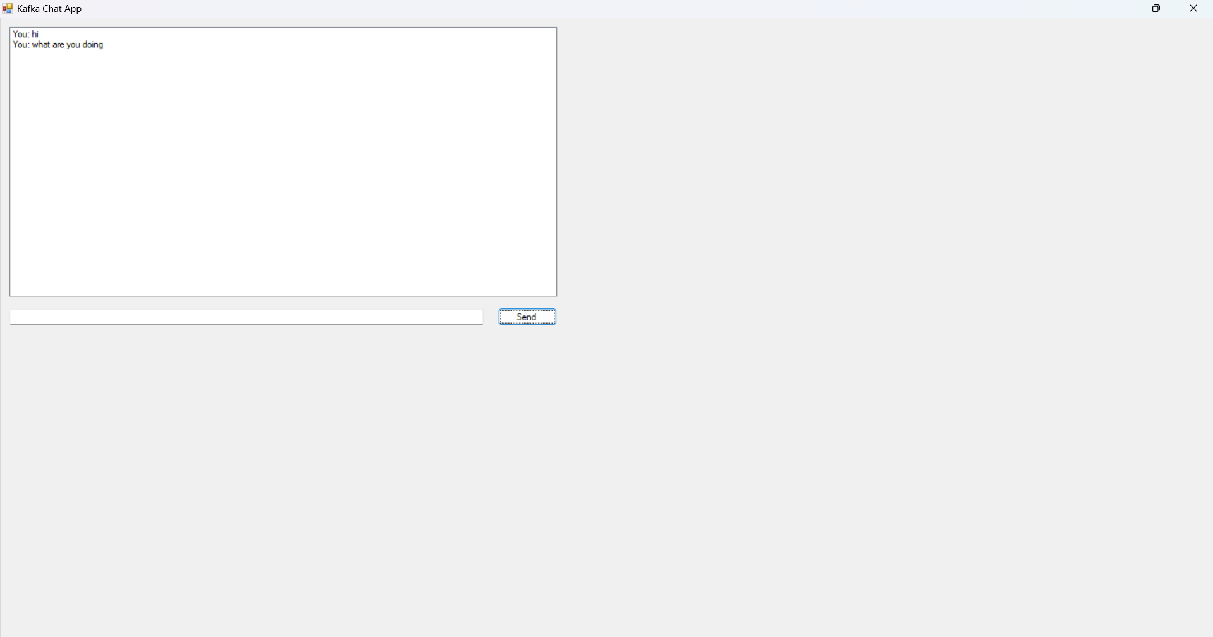  
  
**4. Kafka Server Running**   
  
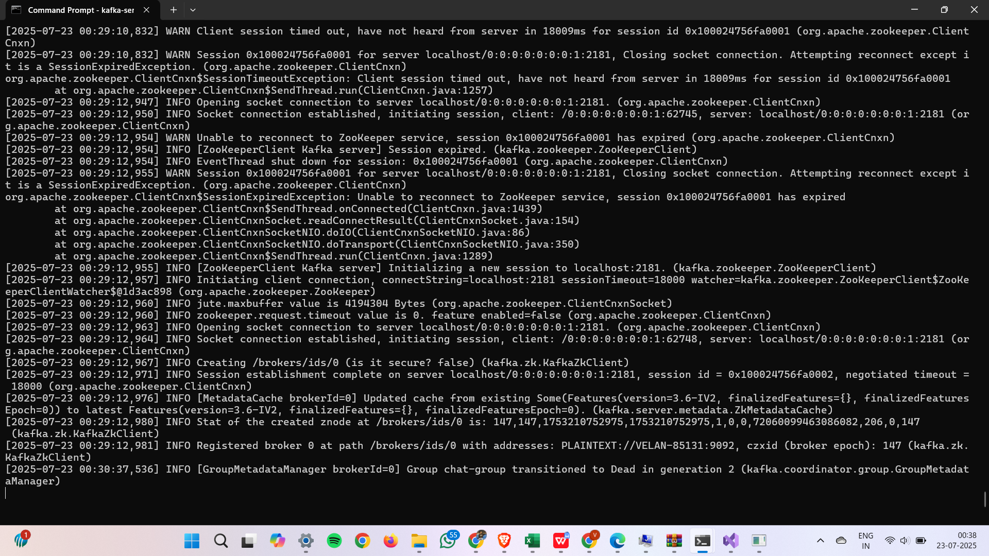  
  
**5. Zookeeper Running:**